Amazon Elastic Kubernetes Service (EKS)

Amazon Elastic Kubernetes Service (EKS) is a managed service by AWS that makes it easy to run Kubernetes for deploying, managing, and scaling container apps without worrying about complex setup.
Simple Key Features
- Managed Control Plane: AWS handles the Kubernetes control system, taking care of updates, scaling, and security automatically.
- Flexible Compute: You can use different types of AWS server instances, including cost-effective and powerful options.
- Strong Security: Integrated with AWS Identity and Access Management (IAM) for secure user and workload permissions.
- Multiple Storage Options: Supports AWS storage services like EBS, S3, and EFS for your app’s data needs.
- Monitoring Tools: Works with AWS CloudWatch and other tools to track your cluster's health.
- Kubernetes Compatibility: Works with standard Kubernetes tools and apps, so you don’t need to change your workloads.
Common Uses
- Running micro services that need to scale independently.
- Automating app deployments with CI/CD pipelines.
- Support for hybrid setups with both on-premises and cloud environments.
- Running machine learning workloads and batch jobs.
- Modernizing old applications by containerizing them.
- EKS helps you focus on developing apps by taking care of managing Kubernetes infrastructure in a secure, scalable, and integrated way with AWS.

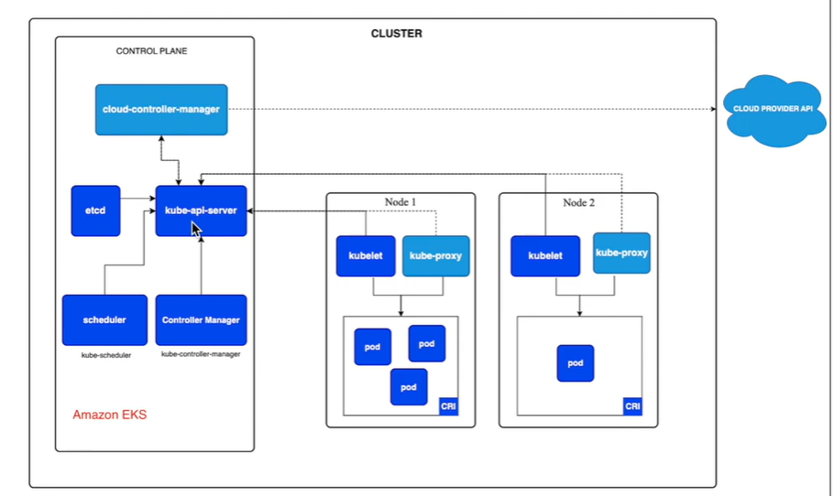

Simple step-by-step guide to create an Amazon EKS cluster:
Steps: 1
- Login to AWS console and search EKS
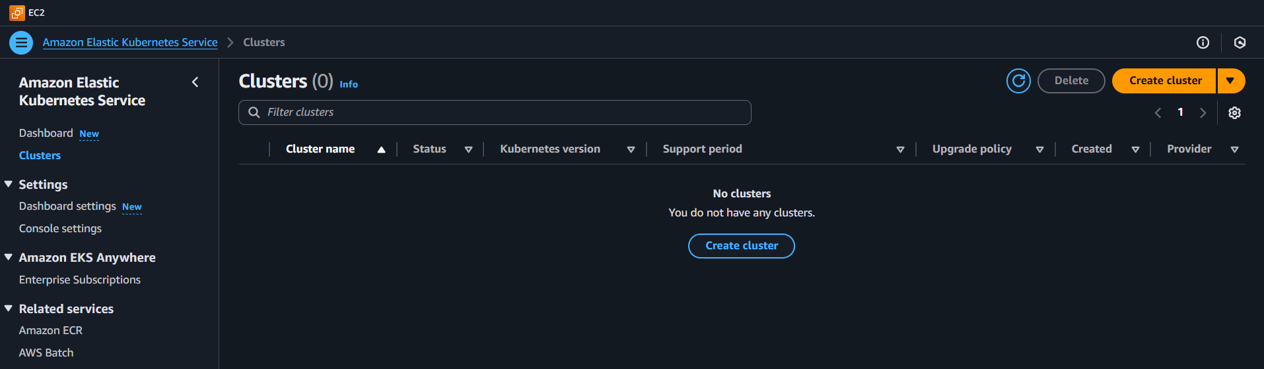

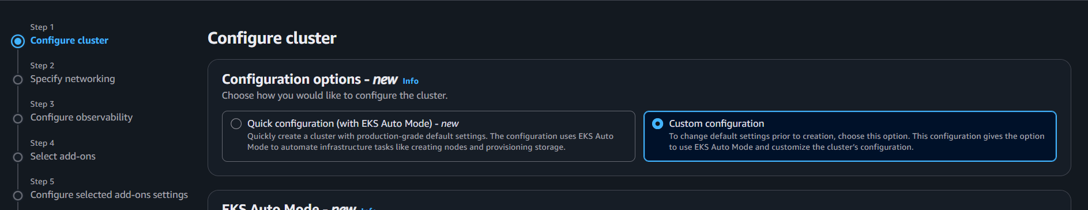

- Disable the auto mode
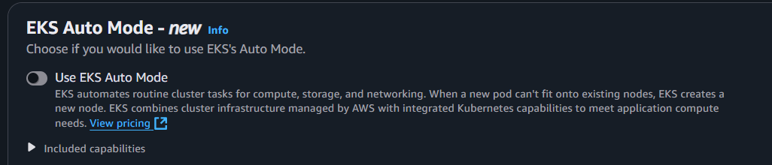

- Give the Eks cluster name
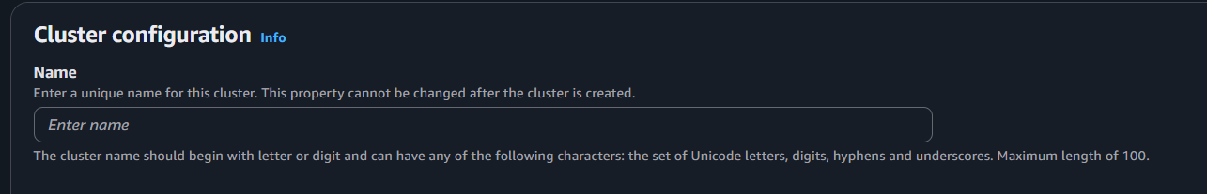

- Cluster IAM role
A cluster IAM role in Amazon EKS is a special AWS identity that grants Kubernetes control plane permission to manage AWS resources on your behalf. It allows EKS to create, modify, and monitor infrastructure like EC2 instances and networking components securely.
In simple terms: The cluster IAM role acts as a trusted "user" with specific permissions that the EKS control plane assumes to run and manage your Kubernetes cluster resources properly without needing permanent access keys.​
This role ensures security by using temporary permissions and limits what EKS can do, helping maintain safe and controlled access to AWS resources.

Explain the role of an IAM role for EKS clusters:

An IAM role for an EKS cluster is a special permission set that allows the EKS control plane to manage AWS resources for your cluster, like creating and managing worker nodes or load balancers. It acts as a trusted identity that EKS assumes to perform necessary actions securely on your behalf.
In simple terms, this IAM role makes sure the Kubernetes control plane has the rights to control AWS infrastructure (such as EC2 instances and networking) needed to run your cluster, without exposing permanent credentials. It helps keep your cluster secure and properly managed.​
Additionally, IAM roles can also be assigned to users or service accounts to control who or what can interact with the cluster, ensuring secure and fine-grained access control within Kubernetes.

FOR EXAMPLE

The IAM role will have permissions like ec2:CreateTags and ec2:DescribeInstances that allow EKS to tag and describe EC2 instances (worker nodes) in your cluster. The role uses the AWS-managed policy AmazonEKSClusterPolicy, which includes all necessary permissions for EKS to create and manage AWS resources required by your cluster.
In practice, this means that when EKS needs to launch or terminate worker nodes, manage networking, or create load balancers for your services, it assumes this IAM role to get permission temporarily. This eliminates the need to store long-term credentials in your cluster and keeps your infrastructure secure.
So, the cluster IAM role acts as a secure trusted identity that allows the EKS control plane to interact with AWS services on your behalf to keep your Kubernetes cluster running smoothly and securely.

Click on create recommended role
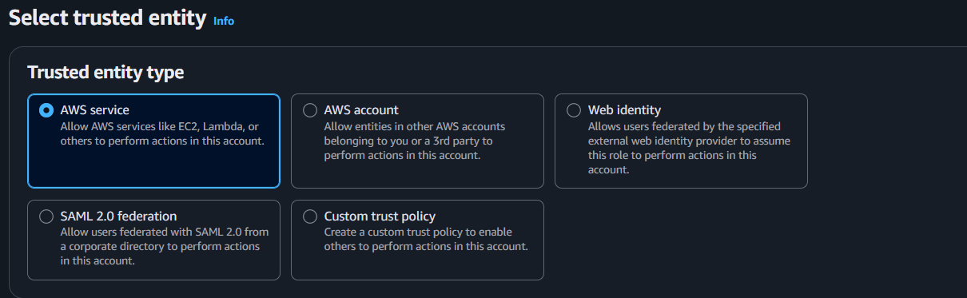

Got Use case and select EKS cluster
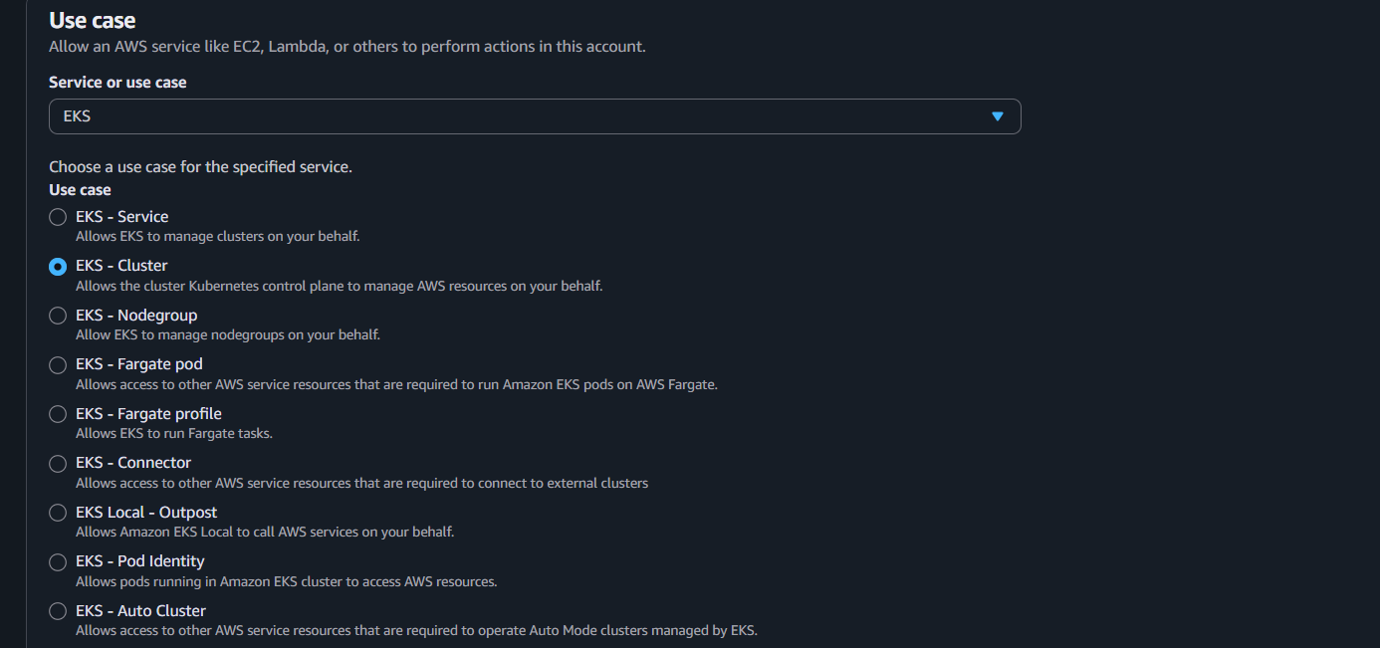

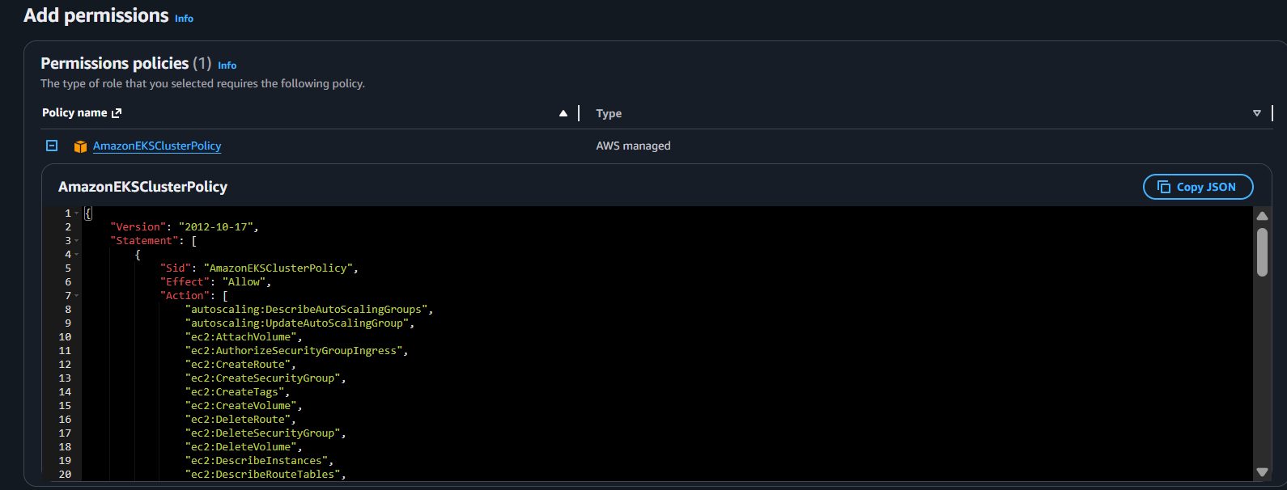

Here, Can EKS has all policy attached

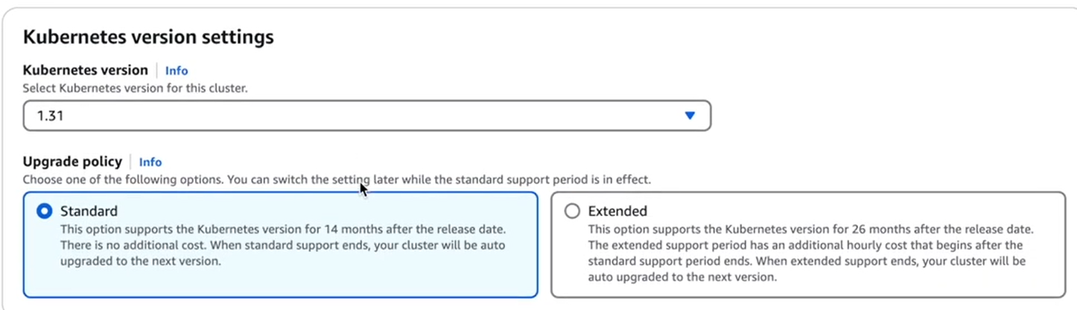
Here, we have specify the kubernetes version 1.31 is latest version kubernetes.
Upgrade, we go with standard, because extended support cost more.

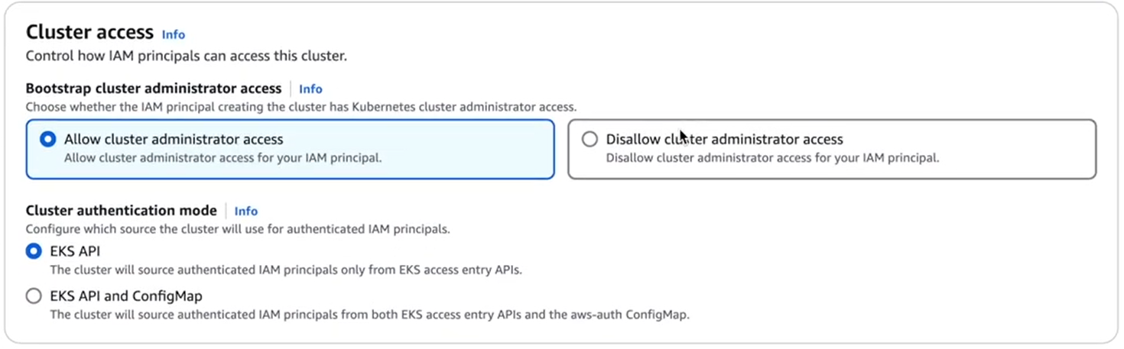
Default action
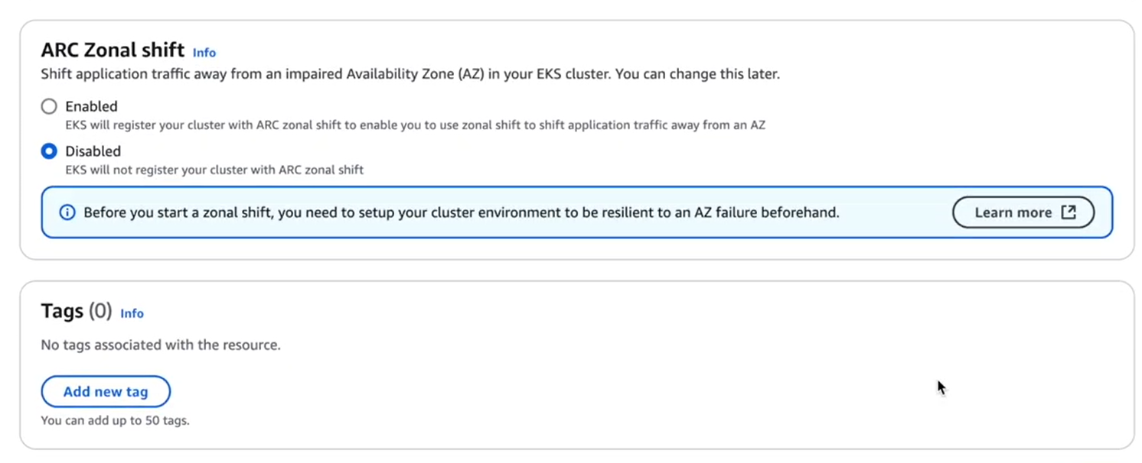

Step: 2
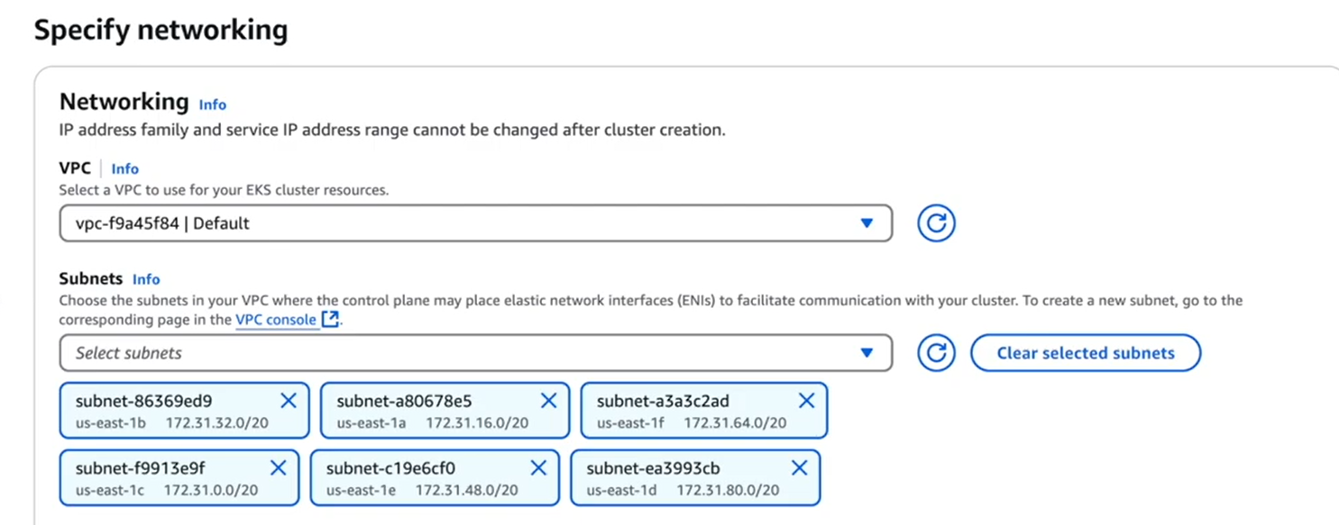
Here, we are selecting the vpc and selecting all private subnet
Note: Private subnets in Amazon EKS are used to host worker nodes that do not have direct access to the internet, which increases security by limiting exposure to external traffic. These nodes can still access the internet for updates and communication through a NAT gateway for outgoing traffic, but inbound traffic from the internet is blocked. This setup helps isolate and protect workloads while public subnets are used for resources like load balancers that need internet access. Using private subnets enhances network isolation, control over traffic, and overall cluster security in EKS environments.

Note: All the public subnet should enable the tags kubernetes.io/role/elb =1
It is required when we create the load balancer our application on browser eks find
VPC-Subnet tags
The tag kubernetes.io/role/elb=1 must be enabled on public subnets when creating an Amazon EKS cluster because it signals to both Kubernetes and the AWS Load Balancer Controller that those subnets can be used for internet-facing load balancers like ALB and NLB.
The tag kubernetes.io/role/elb=1 is enabled on public subnets in EKS to tell Kubernetes which subnets can be used to create internet-facing load balancers automatically. This helps the cluster manage external traffic correctly.
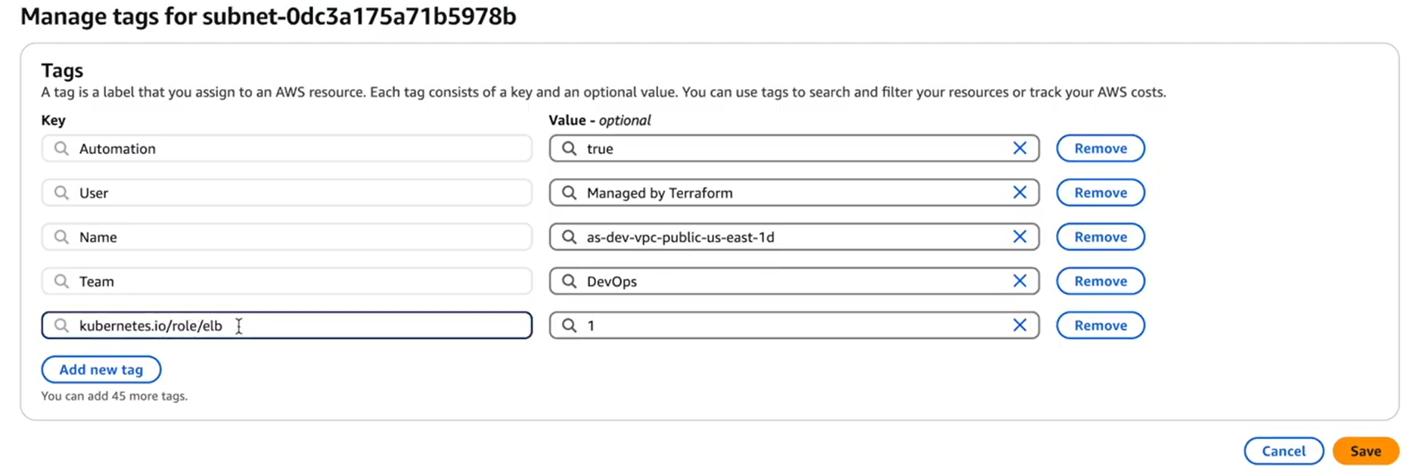
As of now, we don’t need security group and go with default action
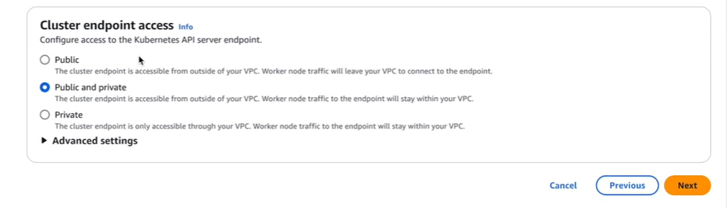
Cluster endpoint access in Amazon EKS refers to how the Kubernetes API server endpoint of a cluster is reachable and controlled. It determines whether the API server is accessible publicly over the internet, privately within the VPC, or both.
Public endpoint access allows the API server to be accessed from the internet, optionally restricted by specified IP ranges (CIDRs).
Private endpoint access restricts the API server access to only resources inside the cluster's VPC, enhancing security by blocking external internet access.
You can enable either one or both simultaneously based on your security and access needs.
This setting controls how you manage communication with the cluster control plane, providing flexibility between accessibility and security.
Step 3
Click on next
Step 4
Add-ons

Eks automatically select the al plugins
Note
Amazon EKS add-ons are software components that extend the functionality of your Kubernetes cluster to provide essential operational capabilities. AWS provides managed add-ons that are integrated, secure, and regularly updated. Key EKS add-ons include:
Amazon VPC CNI plugin: Handles networking for pods, enabling them to communicate with each other and with AWS services.
CoreDNS: Provides DNS service inside the cluster for service discovery.
kube-proxy: Manages network rules to allow communication to pods.
Amazon EBS CSI driver: Enables dynamic provisioning and management of Elastic Block Store volumes.
Amazon EFS CSI driver: For Elastic File System access within pods.
AWS Load Balancer Controller: Manages AWS load balancers for Kubernetes services.
These add-ons simplify cluster management, enhance network and storage integration, and ensure the cluster runs securely and efficiently. They can be managed via the AWS console, CLI, eksctl, or infrastructure-as-code tools. Users can also customize configurations and update add-ons as needed.
Node monitoring agent
The node monitoring agent in EKS is a daemon that runs on worker nodes to continuously monitor their health. It detects issues like kubelet problems, container runtime failures, networking errors, storage capacity, CPU or memory pressure, and even GPU failures in specialized instances. The agent reports node health by updating Kubernetes node status and emitting events, helping administrators identify and address issues proactively.
Amazon EKS Pod Identity
Amazon EKS Pod Identity is a feature that simplifies managing AWS IAM permissions for Kubernetes pods by associating an IAM role directly with a Kubernetes service account. This way, pods using that service account can securely access AWS resources with scoped permissions without embedding or sharing AWS credentials.

Once require plugins are selected click on next.

Step 5: configure selected add-ons settings
Here we can see the version of selected plugins
Based security concerns we have to update the version of the plugins
Click on next
Step 6: click on next
Here we can see all the details about configuration. Cluster will take 10 to 20 minutes to create.
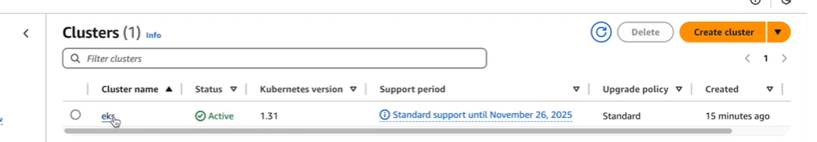
Cluster status is active
Go to resource: here we can see the pods but they are in pending state.
Because:-
In Amazon EKS, you provide the compute power your cluster needs by using:
Managed Node Groups: These are groups of EC2 virtual machines that you manage and scale. You pick the instance types and number of nodes. This gives you control over the machines running your applications.
Fargate Profiles: This is serverless compute where AWS runs your pods for you without managing servers. You just tell EKS which pods should run on Fargate using labels or namespaces. It’s easier to manage but better suited for smaller or bursty workloads.
You can use either option or both together depending on your workload needs. Managed Node Groups give you more control; Fargate simplifies management by removing the need to provision servers.

Creating manage node group
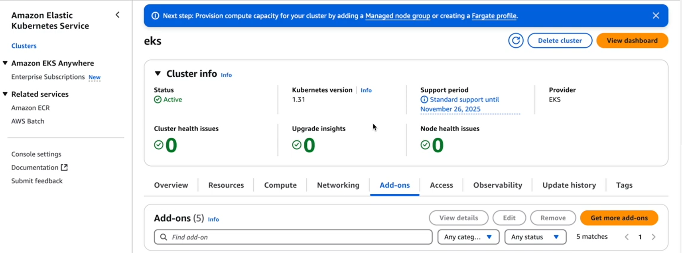
Click on compute: -
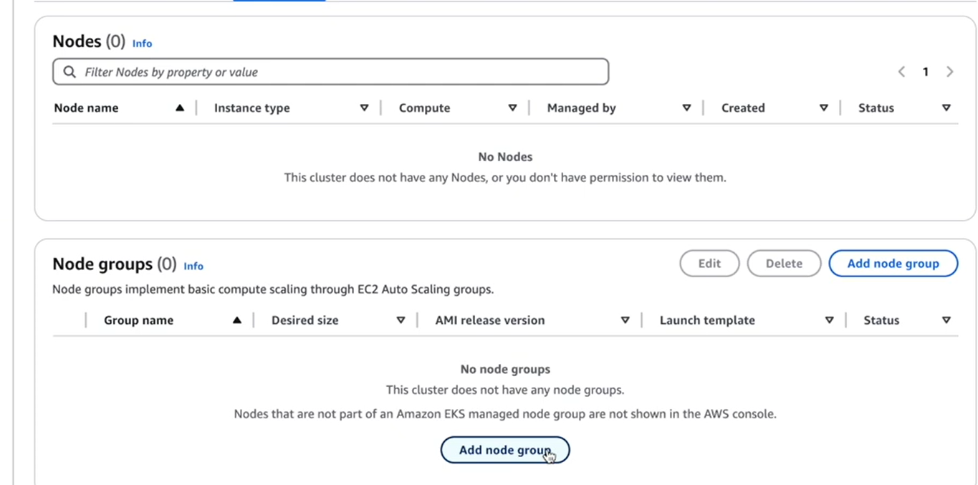
Click on Node group
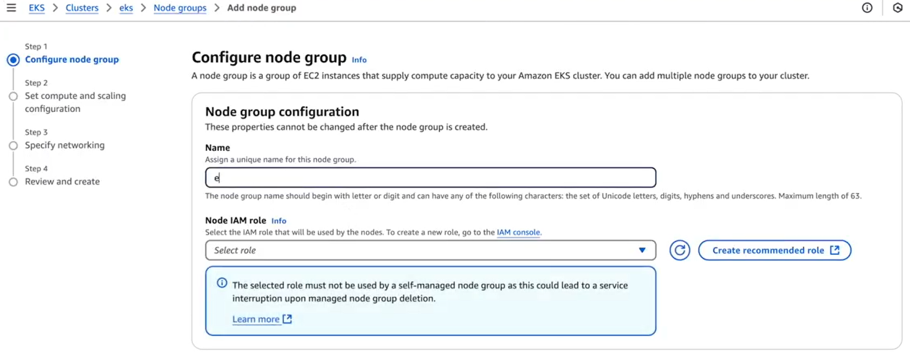
Give name for node
Then we have attach IAM policy for that node (ec2)
Click on (create recommended role)

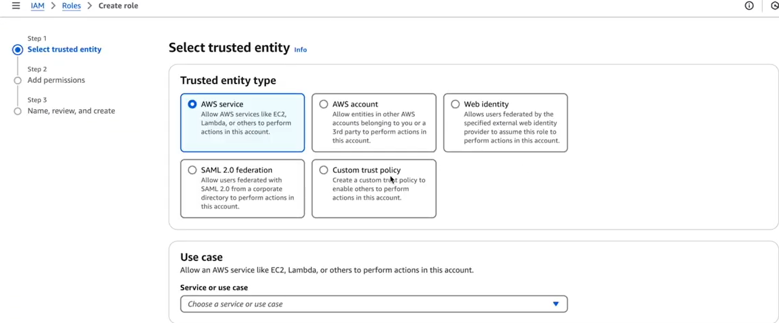
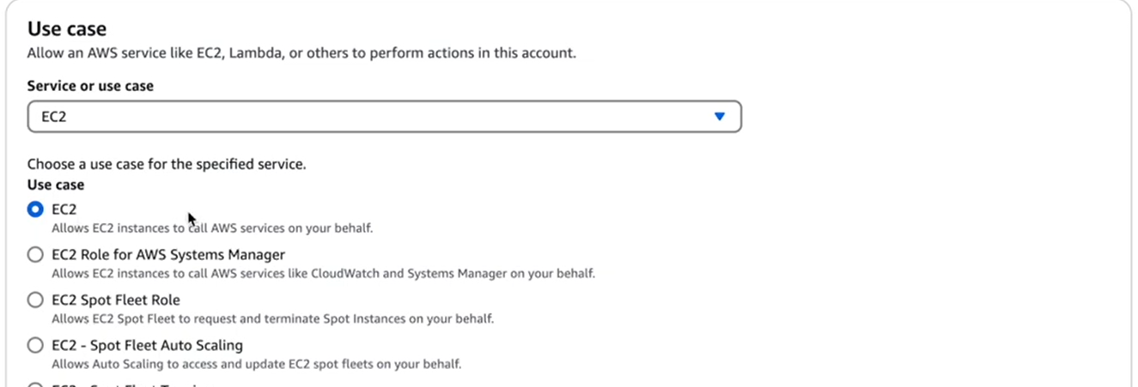
Select the use case ec2
Creating node means we are creating ec2 instance
Next
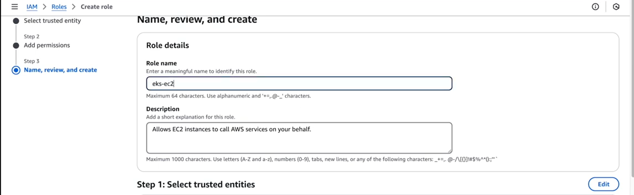
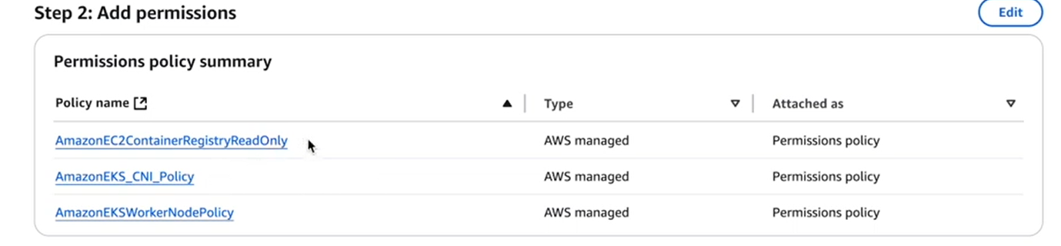
Click on create role
And select the role and attaché it
Check on next

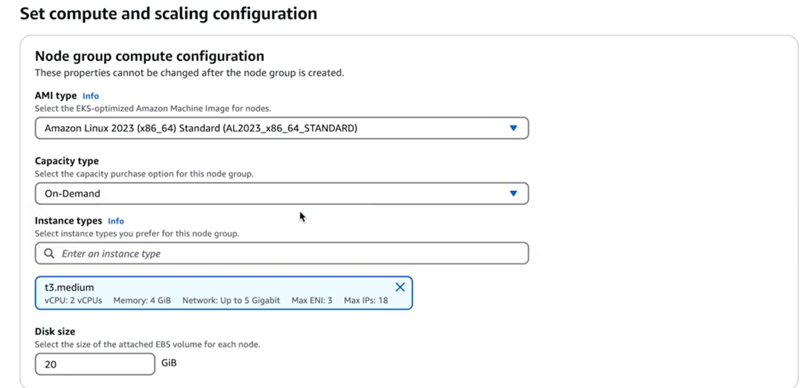
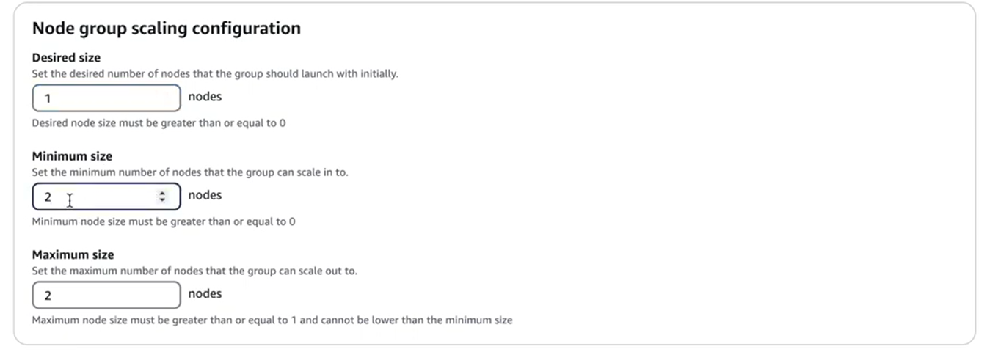
Node group scaling in Amazon EKS is simple:
Minimum size: The smallest number of nodes you always want running.
Maximum size: The largest number of nodes the group can scale up to.
Desired size: The target number of nodes you want right now. The system adds or removes nodes to reach this.
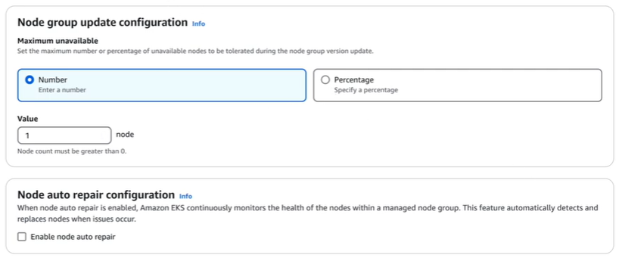
During a node group update in Amazon EKS, pods are updated gradually to avoid downtime. This is done using a rolling update strategy that controls how many pods get updated at a time.
For example, if you have 5 pods, the update process may update 2 pods first, wait for them to become healthy and ready, and then proceed to update the remaining pods. This gradual approach ensures that some pods remain available to serve traffic while others are being updated.
In summary:
Updates happen in batches, not all pods at once.
The process respects availability through Pod Disruption Budgets.
Rolling updates minimize downtime by ensuring some pods stay running during updates.
This keeps your application reliable as nodes and pods get upgraded in the cluster.

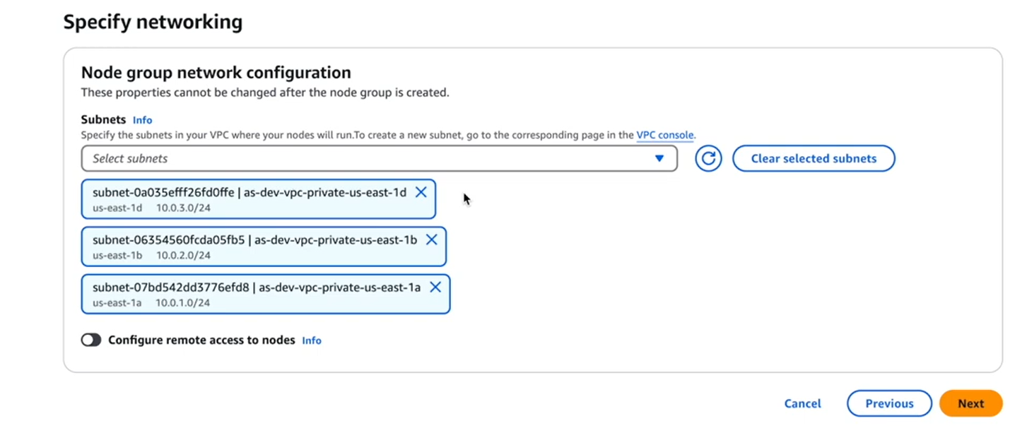
Again we have specify the private subnet, because applications are running private subnet. We access it through load balancer.

Configure remote access to node.
The purpose of configuring remote access to an Amazon EKS node is to enable administrators and engineers to connect directly to the worker nodes for troubleshooting, monitoring, manual configuration, and debugging. Remote access helps:
Investigate issues that cannot be diagnosed through Kubernetes tools alone.
Access log files, system metrics, and processes running on the node.
Perform manual system updates, network testing, or configuration changes.
Validate node health and connectivity.
Debug application or infrastructure problems at the node level.
Overall, remote access provides greater visibility and control over the underlying infrastructure supporting your Kubernetes workloads, helping maintain cluster reliability and performance. However, it should be secured properly to prevent unauthorized access.

Click on next and see the all config
The node group is create successfully
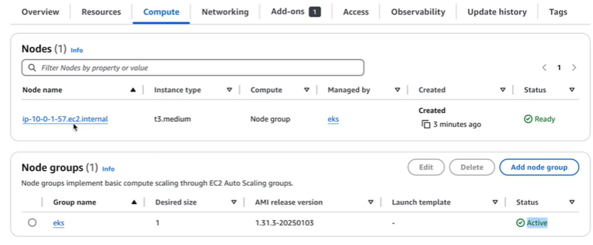
Pod are created. If you go any of them you see pods running.
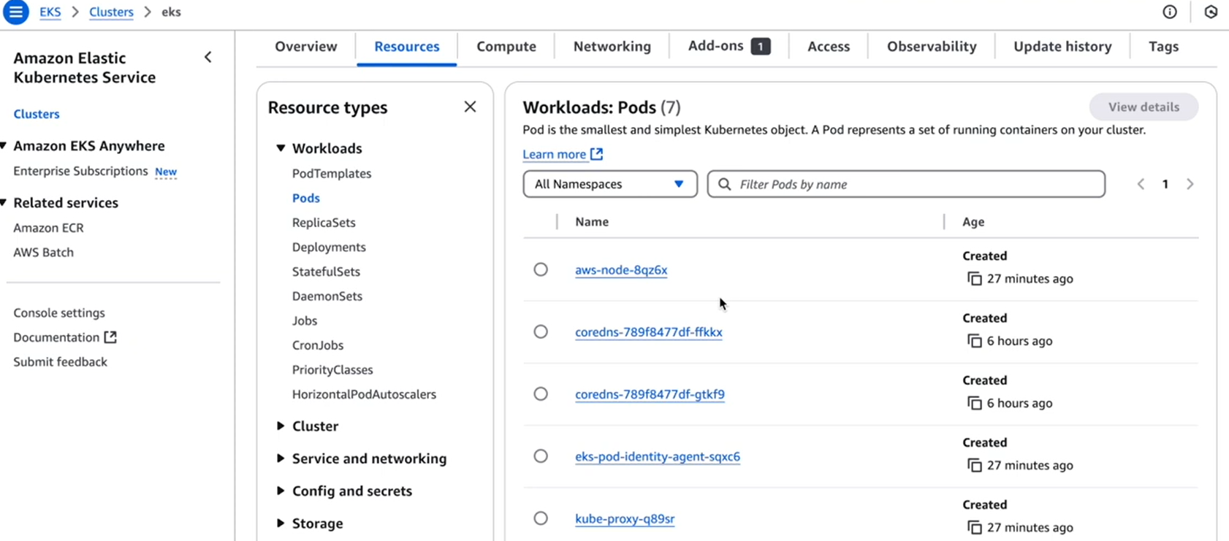

When we go inside pod
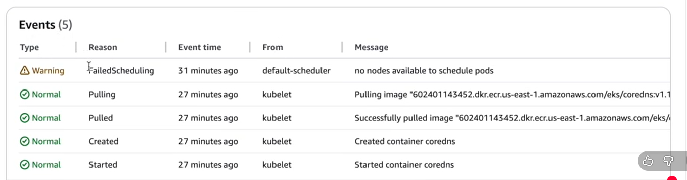
initially, I got failed because.
-------------------------------------------------------------------------------------------------------------------
Connecting EKS using local machine

AWS CLI install on Linux Ubuntu and update instruction (bash script)
#!/bin/bash
# Update package lists
echo "Updating package lists..."
sudo apt-get update -y
# Install unzip and curl if not installed
echo "Installing dependencies..."
sudo apt-get install -y unzip curl
# Download AWS CLI installer
AWS_CLI_ZIP="awscliv2.zip"
DOWNLOAD_URL="https://awscli.amazonaws.com/awscli-exe-linux-x86_64.zip"
echo "Downloading AWS CLI installer..."
curl "$DOWNLOAD_URL" -o "$AWS_CLI_ZIP"
# Unzip installer
echo "Unzipping installer..."
unzip -o "$AWS_CLI_ZIP"

# Install or update AWS CLI
echo "Installing/updating AWS CLI..."
sudo ./aws/install --update
# Verify installation
echo "AWS CLI version installed:"
aws --version
# Clean up installer files
echo "Cleaning up..."
rm -rf aws "$AWS_CLI_ZIP"
echo "AWS CLI installation/update complete."

Then we have to install kubectl command
Installation script for kubectl
curl -LO https://dl.k8s.io/release/$(curl -L -s https://dl.k8s.io/release/stable.txt)/bin/linux/amd64/kubectl
chmod +x kubectl
sudo mv kubectl /usr/local/bin/
kubectl version --client

Once both kubectl and aws cli installed:

We have establish aws to local machine.
Go to aws console IAM User security credentials Access key Create access key

Command:
aws configure
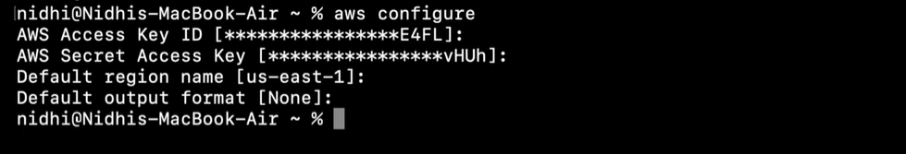

Command to connect EKS from local machine command prompt
Use the AWS CLI to create or update your kubeconfig file with the cluster details:
text
aws eks --region <region> update-kubeconfig --name <cluster_name>

Kubetctl get pod –A (-A mean all name spaces)
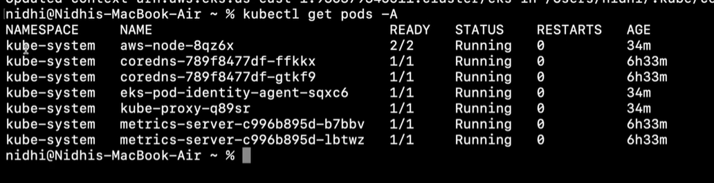
Here, we can see all the add’s on
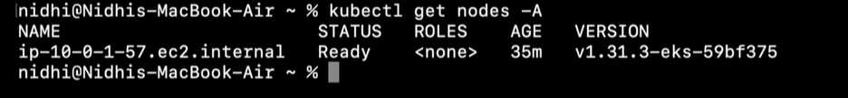
That we have created

Deploying simple application on EKS
---
Deploy.yml
apiVersion: v1
kind: Namespace
metadata:
name: eks-sample-app
---
apiVersion: apps/v1
kind: Deployment
metadata:
name: eks-sample-linux-deployment
namespace: eks-sample-app
labels:
app: eks-sample-linux-app
spec:
replicas: 3
selector:
matchLabels:
app: eks-sample-linux-app
template:
metadata:
labels:
app: eks-sample-linux-app
spec:
affinity:
nodeAffinity:
requiredDuringSchedulingIgnoredDuringExecution:
nodeSelectorTerms:
- matchExpressions:
- key: kubernetes.io/arch
operator: In
values:
- amd64
- arm64
containers:
- name: nginx
image: public.ecr.aws/nginx/nginx:1.23
ports:
- name: http
containerPort: 80
imagePullPolicy: IfNotPresent
nodeSelector:
kubernetes.io/os: linux

Namespaces allow segregation of resources, control of access and policies, and easier multi-tenant cluster management. This is especially useful in environments like EKS (Amazon Elastic Kubernetes Service), where multiple applications or teams share the same cluster.
In summary, this command creates a new isolated namespace "eks-sample-app" in your Kubernetes cluster where you can deploy resources independently from other namespaces.
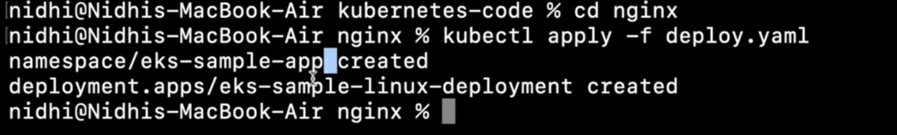
Nginx pod is created
Kubectl get pod –A
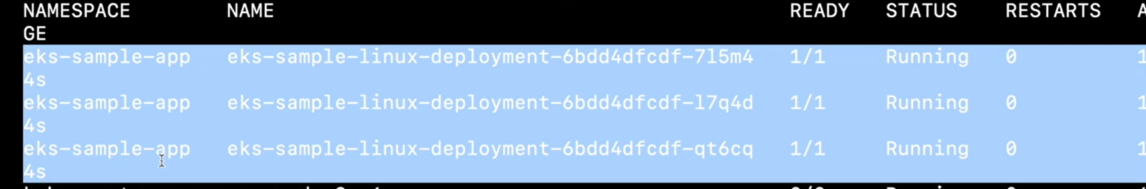
Same way we can check in the EKS as well
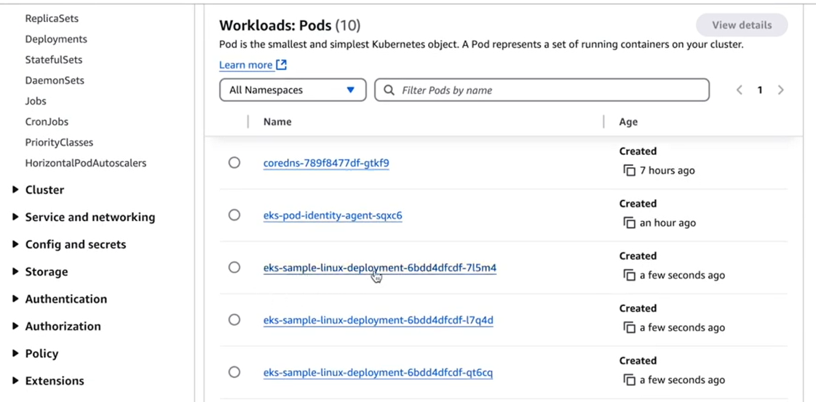
We can check the event in both CLi and aws console
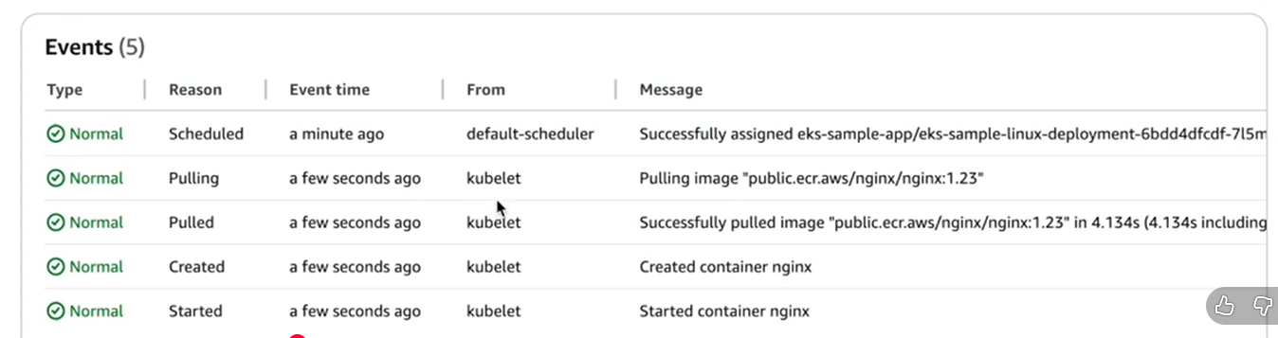

We have to check weather application is running inside the pod.

Go to inside the pod
To enter a running Kubernetes pod and get an interactive shell, use the kubectl exec command. The most common method is:
kubectl exec -it <pod-name> -- /bin/bash
Replace <pod-name> with the actual name of your pod.
If your container uses sh instead of bash, use /bin/sh.
For pods with multiple containers, specify the container name:
kubectl exec -it <pod-name> -c <container-name> -- /bin/bash
If your pod is in a specific namespace, add the -n flag:
kubectl exec -it <pod-name> -n <namespace> -- /bin/bash
This command opens a shell inside your pod, letting you run commands interactively for debugging or maintenance.

Once we enter the pod:
Run the command:
# curl http://localhost
it will display the out put
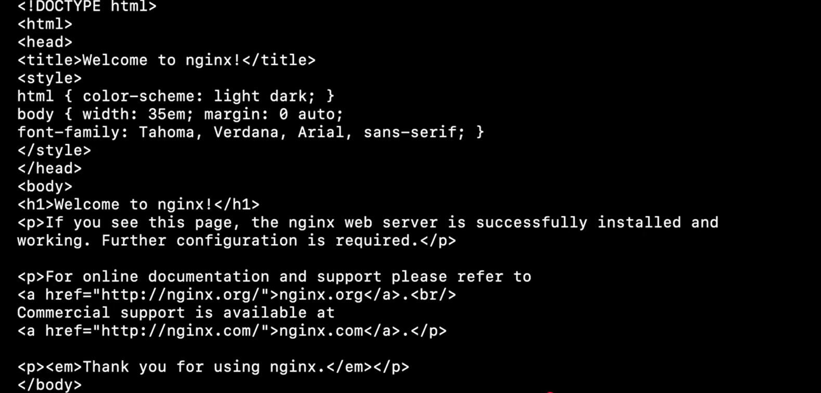

Creating cluster IP
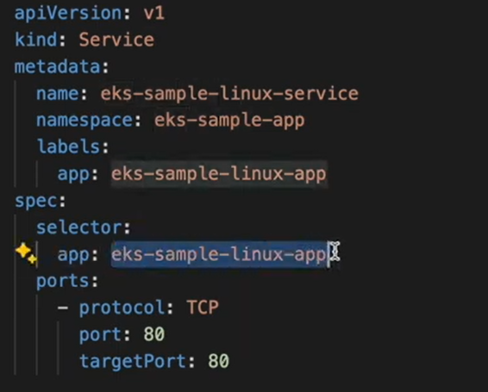

Cluster IP is created
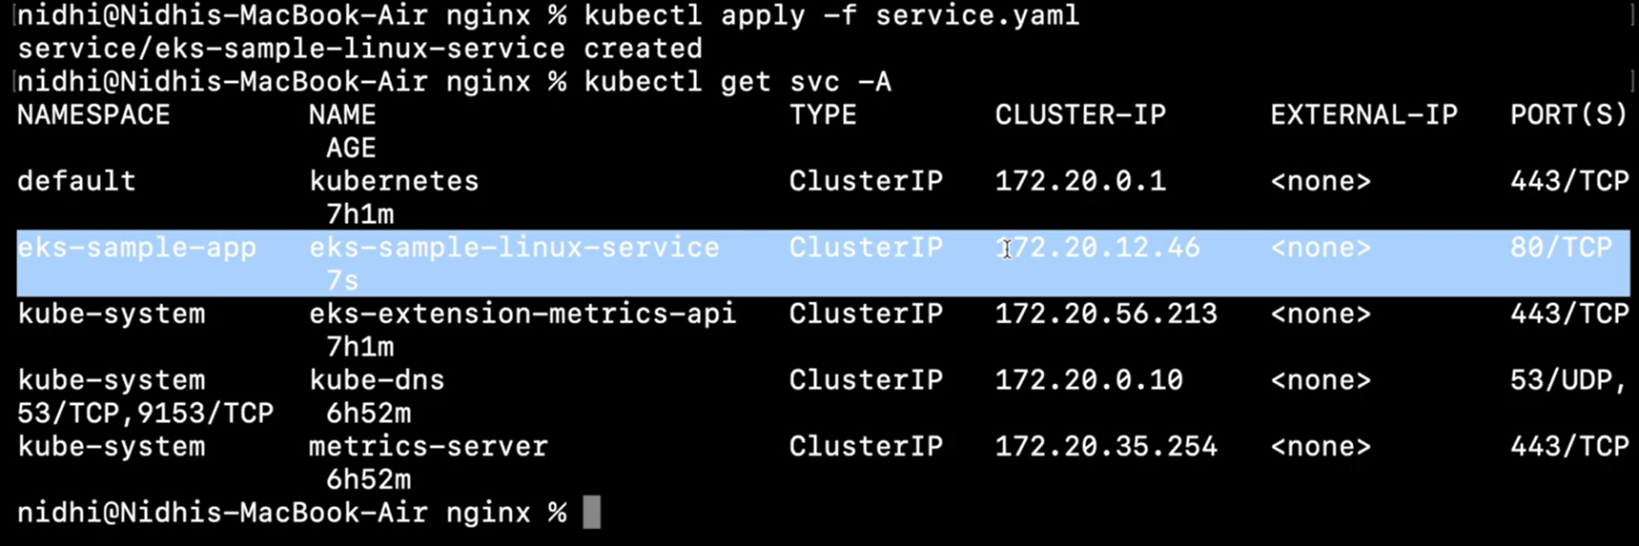

This cluster ip is created to deployment which has 3 replica.
AWS Load Balancer Controller

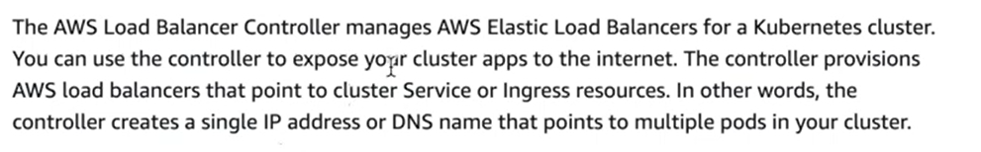
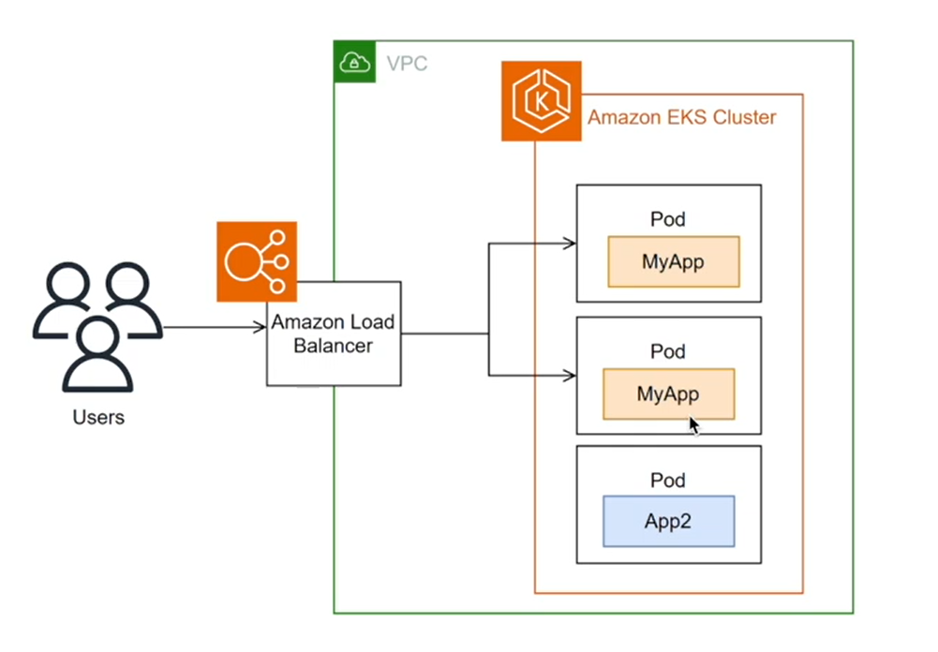

AWS Load Balancer Controller in an EKS cluster is a tool that automatically manages AWS load balancers to help direct internet traffic to applications running inside the Kubernetes cluster.
Here's a simple explanation:
When you create a Kubernetes service of type LoadBalancer, the controller creates an AWS Network Load Balancer (NLB). This kind of load balancer works at the network level (TCP/UDP) and efficiently routes traffic from outside the cluster to the nodes or pods inside.
When you use a Kubernetes Ingress resource, the controller creates an AWS Application Load Balancer (ALB). This load balancer works at the application level (HTTP/HTTPS) and can route traffic based on URLs or hostnames, supporting advanced features like SSL termination.
The controller runs inside the cluster and watches for services or ingress resources, automatically creating and updating the appropriate AWS load balancer as needed.
This setup provides a reliable way for users or clients outside the cluster to reach your applications securely and with high availability.
Annotations in your Kubernetes resource files can customize how the load balancers are created and behave.
In short, the AWS Load Balancer Controller simplifies exposing your Kubernetes applications to the internet by managing AWS load balancers based on your Kubernetes configurations without manual intervention.
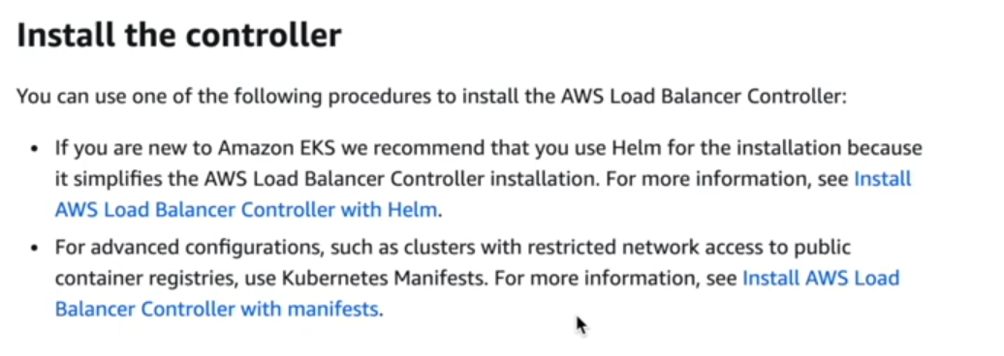
In kubernetes, load balancing can will be done in two ways:
- Using kubernetes manifest file
to enable load balancing using a Kubernetes manifest, you typically define a Service in a YAML file. This service manages and distributes traffic to a set of pods based on labels, balancing load automatically.

Basic Steps
1) create a Kubernetes Deployment manifest to launch multiple replicas (pods) of your application.
2) Create a Service manifest, which selects those pods using labels and exposes them using the desired service type.

Service.yml
apiVersion: v1
kind: Service
metadata:
name: my-app-service
spec:
selector:
app: my-app # Matches pods with this label
ports:
- protocol: TCP
port: 80 # Service port
targetPort: 8080 # Pod port
type: ClusterIP # for internal load balancing; use LoadBalancer for external

- Using helm (Installing AWS load balancer controller with helm)

Requirement for Helm
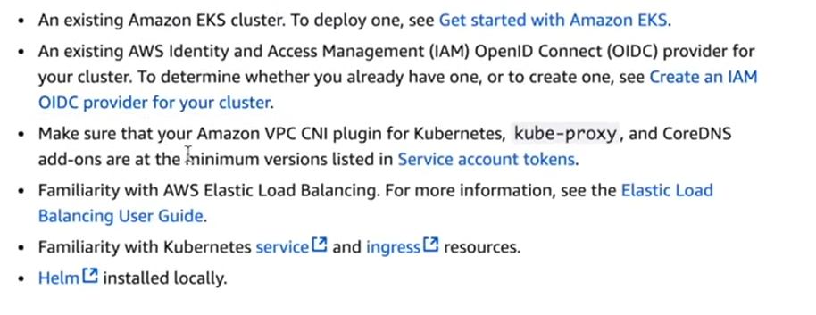

Steps to create Helm:

- Frist, we have to create one aws EKS cluster.

- AWS EKS cluster needs an OIDC (OpenID Connect) provider, which acts like a trusted ID checker. This lets your cluster securely verify which pods and users can access AWS resources. You can check if you already have one or create it using AWS’s guide. This setup helps keep your cluster secure and is a best practice for running Kubernetes on AWS.

- The purpose of an OIDC (OpenID Connect) provider is to securely verify user identities and provide basic profile information to applications. It acts as a trusted service that confirms who a user is, so apps and services do not need to manage user passwords directly. This process helps improve security and enables features like single sign-on (SSO), allowing users to access multiple applications with one login. In AWS, an OIDC provider also helps your Kubernetes cluster connect to AWS services securely by managing permissions and authentication.

- It act as bridge between kubernetes and aws.

- 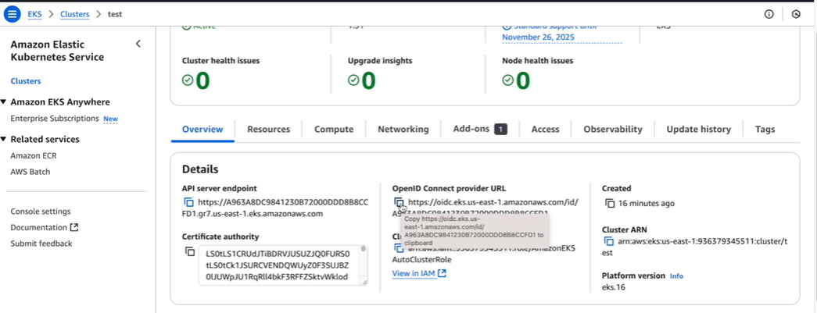

Goto EKS cluster Overview copy the Open Connect provide URL

Goto IAM
Goto IAM Identity provider add provider
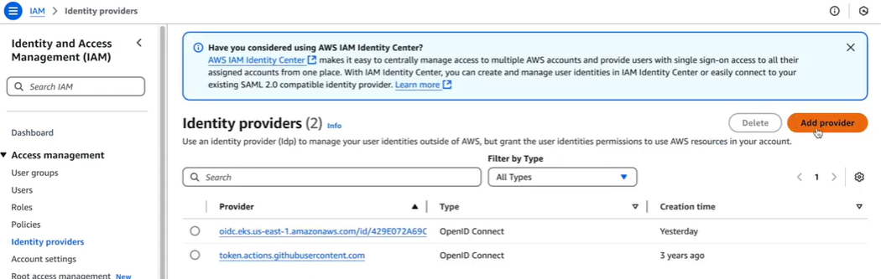

Select OpenID Connect and paste the link in Provider URL
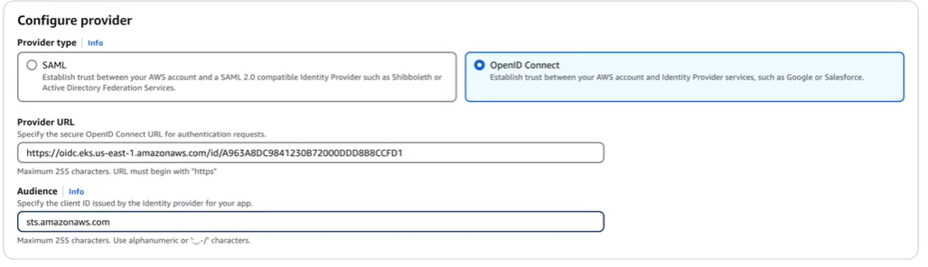
Creating IAM Policy
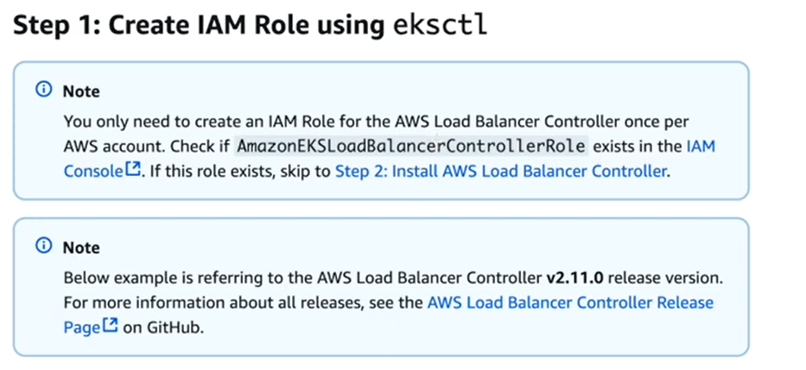
Download an IAM policy for the AWS Load Balancer Controller that allows it to make calls to AWS APIs on your behalf.

curl -O https://raw.githubusercontent.com/kubernetes-sigs/aws-load-balancer-controller/v2.14.1/docs/install/iam_policy.json

When we open above link ,we will get long policy script.
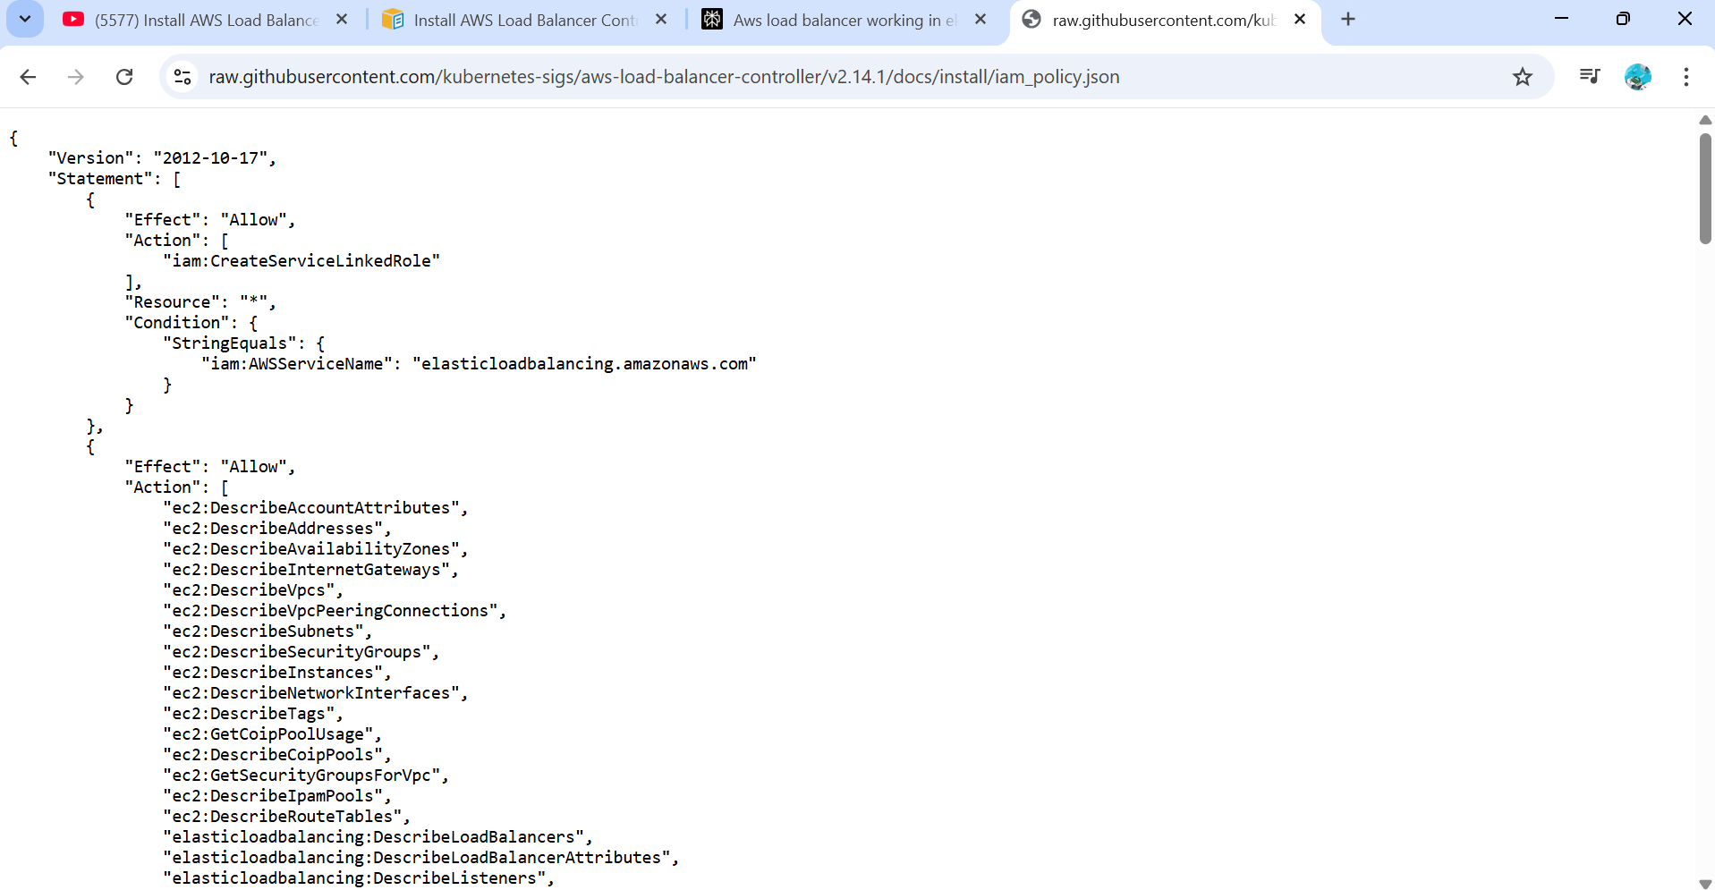

Code entire code
Then Go to IAM Polices
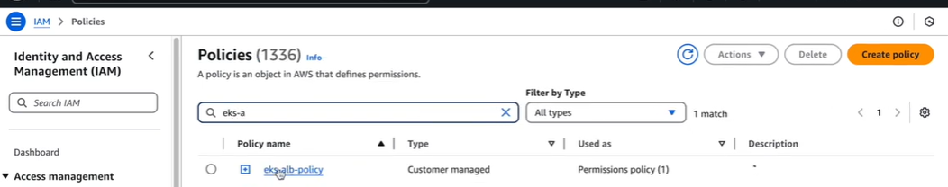
Create policy and paste the above code here

Initially we created a role name while lunching EKS
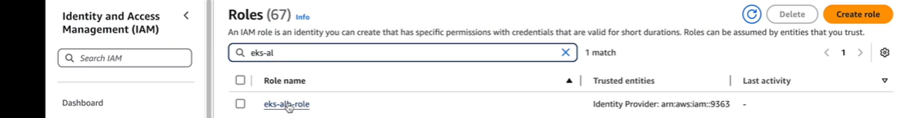

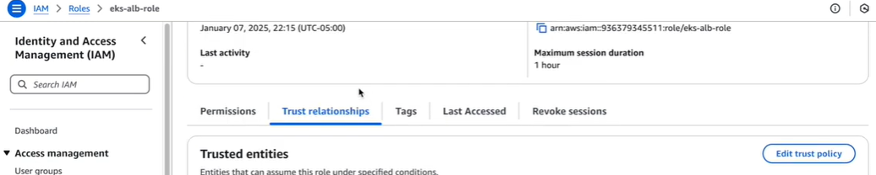

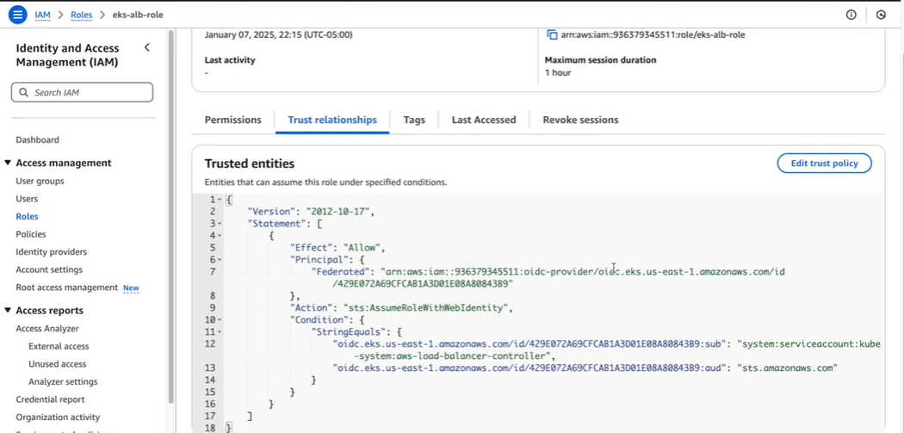
In Trust relationship, here we have to put newly generated identity provider
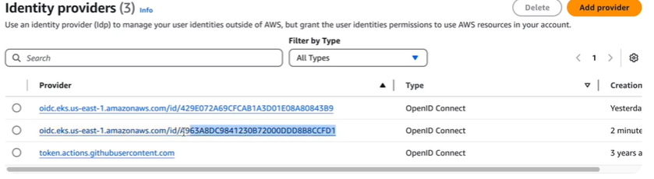
Replace in trust polices
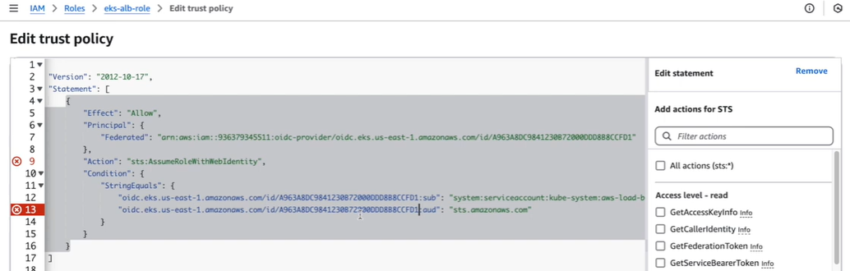

Creating service account
A Kubernetes service account is like a special ID for applications running inside the cluster. It helps the apps prove who they are when they talk to the Kubernetes system.
Why is it helpful?
It lets apps securely access Kubernetes resources without using human user accounts.
You can control what each app is allowed to do, keeping your cluster safe.
It is used automatically for pods that need to interact with Kubernetes or other services.
In simple terms, a service account gives an app a trusted identity for secure communication inside a Kubernetes cluster.
Service Account manifest (serviceaccount.yaml)
apiVersion: v1
kind: ServiceAccount
metadata:
name: my-service-account
namespace: default

For example:
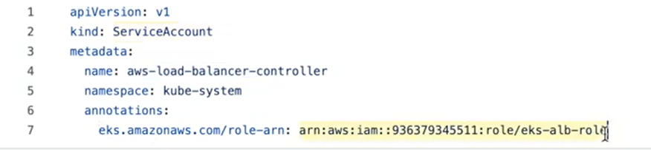
If annotation does not happen kubernetes service account not able to communicate aws resource. It will show access denied
This role should be have all the policies that have provided by the aws documentation and trust policy using oID . if these things are not proper access denied error will occur
Kubectl apply –f serviceaccount.yml
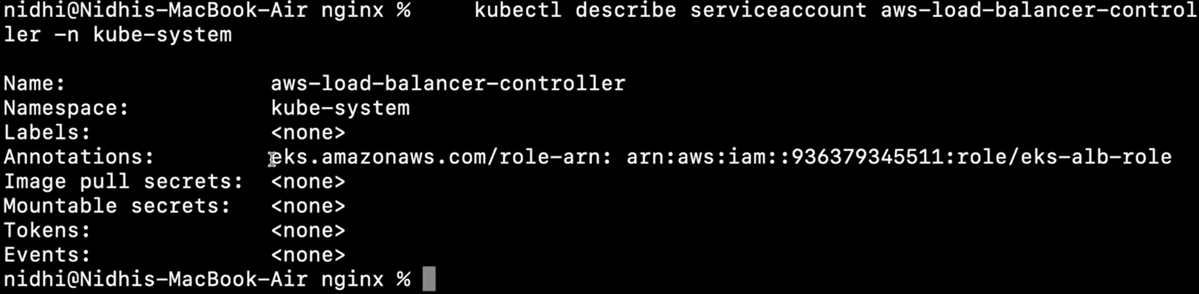
kubectl describe serviceaccount aws-load-balancer-controller -n kube-system
is used to display detailed information about the aws-load-balancer-controller service account in the kube-system namespace.
What the output shows:
Metadata about the service account such as its name, namespace, labels, and annotations.
Secrets associated with the service account (usually tokens for authentication).
Any image pull secrets.
Events related to the service account.
Details about how this service account is used to authenticate and authorize the AWS Load Balancer Controller to interact securely with the Kubernetes API and AWS resources.

Install AWS load Balancer Controller
Frist we have install the helm in local machine or ec2
Helm.sh (Bash script)
#!/bin/bash
# Set Helm version - update this as needed
HELM_VERSION="v3.16.2"
# Download Helm tarball
curl -O https://get.helm.sh/helm-${HELM_VERSION}-linux-amd64.tar.gz
# Extract the tarball
tar xvf helm-${HELM_VERSION}-linux-amd64.tar.gz
# Move helm binary to /usr/local/bin for system-wide usage
sudo mv linux-amd64/helm /usr/local/bin/helm
# Clean up downloaded files
rm helm-${HELM_VERSION}-linux-amd64.tar.gz
rm -rf linux-amd64

OR try below command for install hel
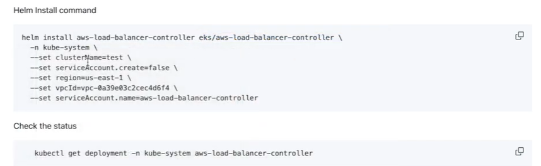
Once it’s done we have to run the below command
Add the eks-charts Helm chart repository. AWS maintains this repository on GitHub
. helm repo add eks https://aws.github.io/eks-charts

Update your local repo to make sure that you have the most recent charts.
helm repo update eks
Note : before creating ingress resource whatever vpc we have minimum 2 public have the tag kubernetes.io/role/elb.

Creating ingress resource

Kubernetes Ingress is like a smart doorway that controls how users from outside can reach your applications running inside a Kubernetes cluster. It uses rules to decide where to send incoming web traffic based on things like website addresses or paths.
Instead of giving each application its own door, Ingress provides one main entry point and then guide’s visitors to the right place. It also helps with things like managing secure connections (HTTPS) and balancing the load of visitors between multiple copies of your app.
In simple words, Ingress makes it easy and safe to let people access your applications from outside the cluster through a single, controlled entrance.
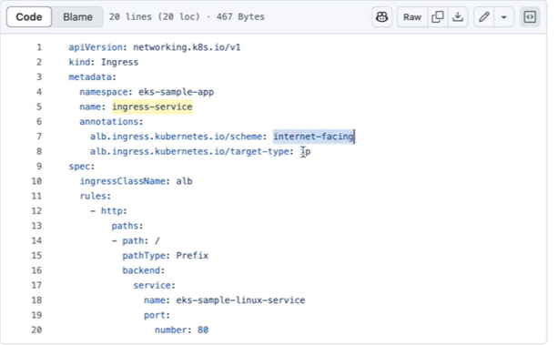
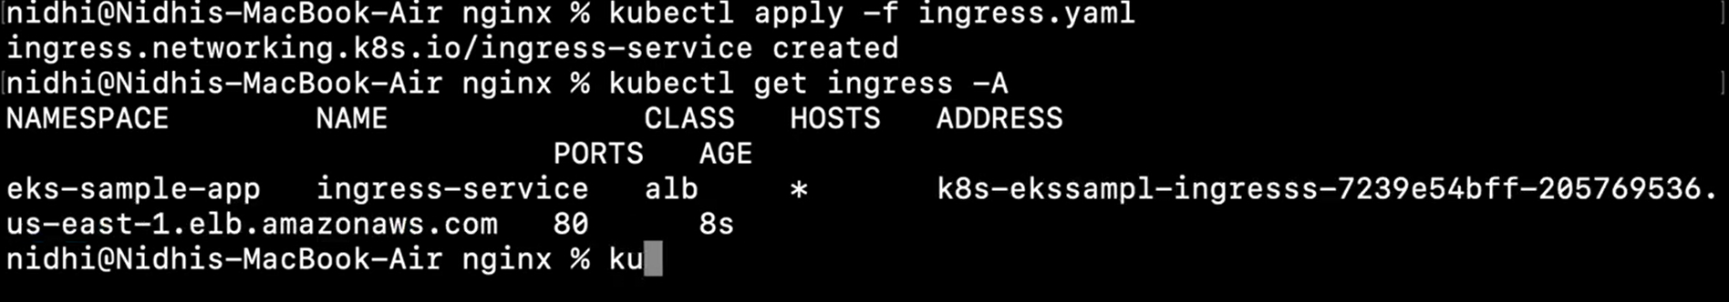

We can check the same in AWS console
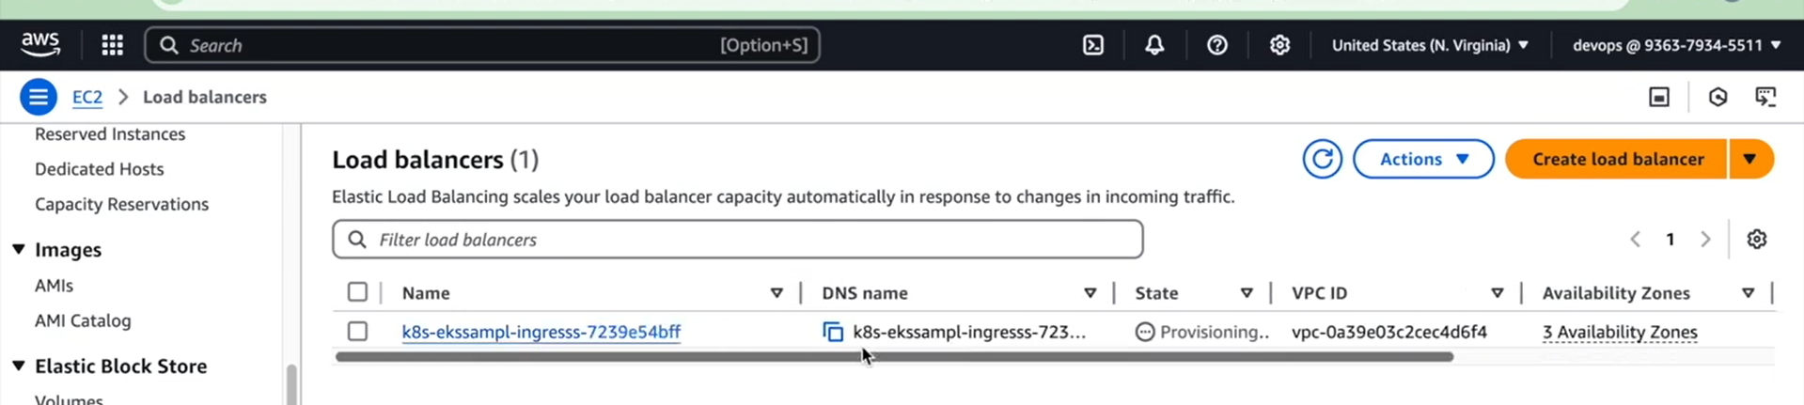
It automatically create the security group. When we run the ingress object.

Kubectl delete ingress
-------------------------------------------------------------------------------------------------------------------------------you tube channel
https://www.youtube.com/watch?v=AhzZQlb_k40&list=PLV1HZYG6utmUvEoLMNnkVSX9XY0aFDPZw&index=7

